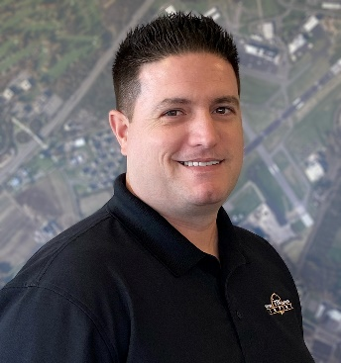

**Joseph DiDonato, Airport Maintenance Supervisor**

**Trenton-Mercer Airport**

**2022 IASS Committee**

Joseph DiDonato is currently the Airport Maintenance Supervisor for the Trenton-Mercer Airport (TTN). TTN is located in the heart of New Jersey and boasts approximately half a million enplanements and over 100,000 operations annually. Mr. DiDonato oversees the maintenance of all grounds and facilities on the 1,345-acre property. Overseen by the County of Mercer, Mr. DiDonato has been a Mercer County employee since 2003, becoming proficient as a Class A CDL holder in all aspects of road construction and airfield maintenance equipment. Mr. DiDonato oversees a staff of approximately 15 specialized maintenance employees, covering field maintenance for all seasons, and various tradesman. Mr. DiDonato oversees all aspects of the day to day maintenance of the grounds to include, mowing, snow fighting, striping and marking, signage, NAVAIDs and more. Mr. DiDonato also oversees the maintenance and operation of all County owned facilities on the Airport, including the Passenger Terminal facility.

Mr. DiDonato has successfully completed both Basic and Advanced ASOS, maintains a Certificate in Management and Leadership from Rutgers University and is currently enrolled in the Rutgers Certified Public Works Management course to obtain a Certified Public Works Manager credential. This background proves vital for Mr. DiDonato as he carries out the responsibility of the departments Operating and Capital budgets, totaling over $8m and $26m respectively.

Mr. DiDonato has a beautiful wife, Ashlee, and two healthy children; Lucia age 6 and Angelo age 6 mos.